21.30: a) The electric field of the Earth points toward the ground, so a NEGATIVE charge will hover above the surface.
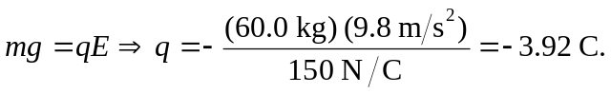
b) 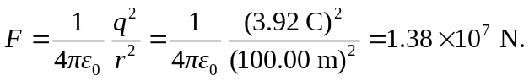 The magnitude of the charge is too great for practical use.

